Power BI Task
Total Marks: 30
You are provided with a dataset containing Coffee Sales data. Your goal is to transform, clean the data and create a data model.
Import Data
● Load the provided Coffee Shop Sales into Power BI. Load both sheets, transactions and stores.
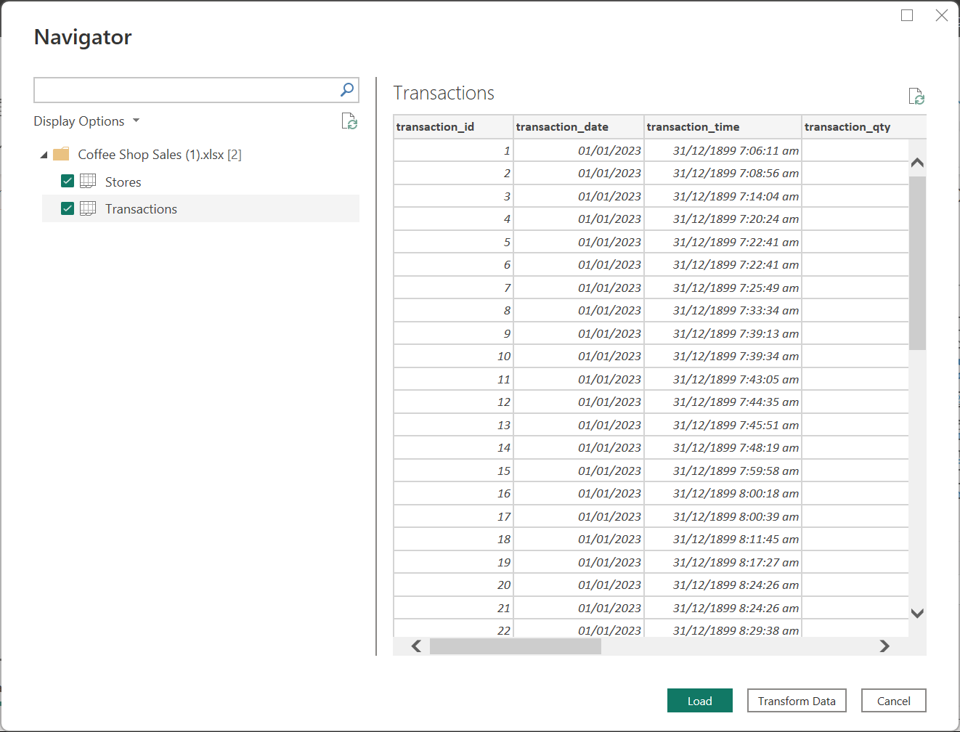
Marks: 8
Data Transformation:
● Check column names, data types, missing values, and error values. (If any) ● Remove blank rows or blank columns, if any.
● Split the Transactions dataset into two smaller tables to normalize the data: a. Create a duplicate of the Transactions table (the dataset you imported) in the query tab. (Right-click on the table and click on duplicate.)
b. Rename the duplicated table to "Products."
c. In the Products table, remove all columns other than
■ Product_id
■ Unit_price
■ Product_category
■ Product_type
■ Product_detail
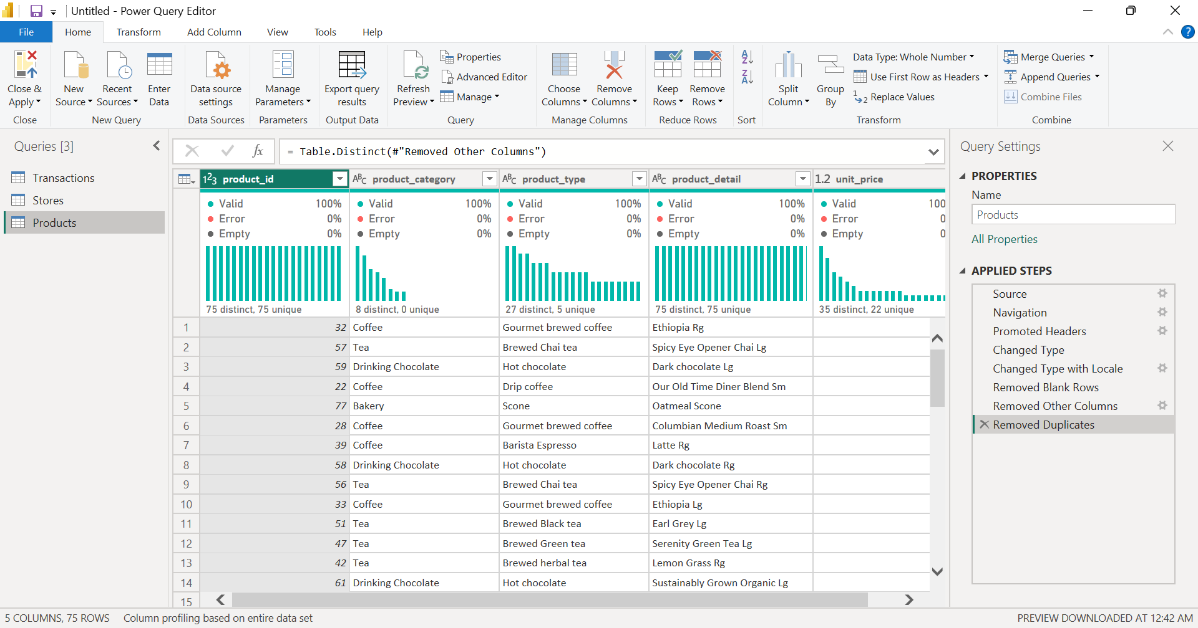
d. In the Transactions table, remove all columns other than
■ transaction_id
■ Transaction_date
■ Transaction_time
■ Transaction_qty
■ Store_id
■ Product_id
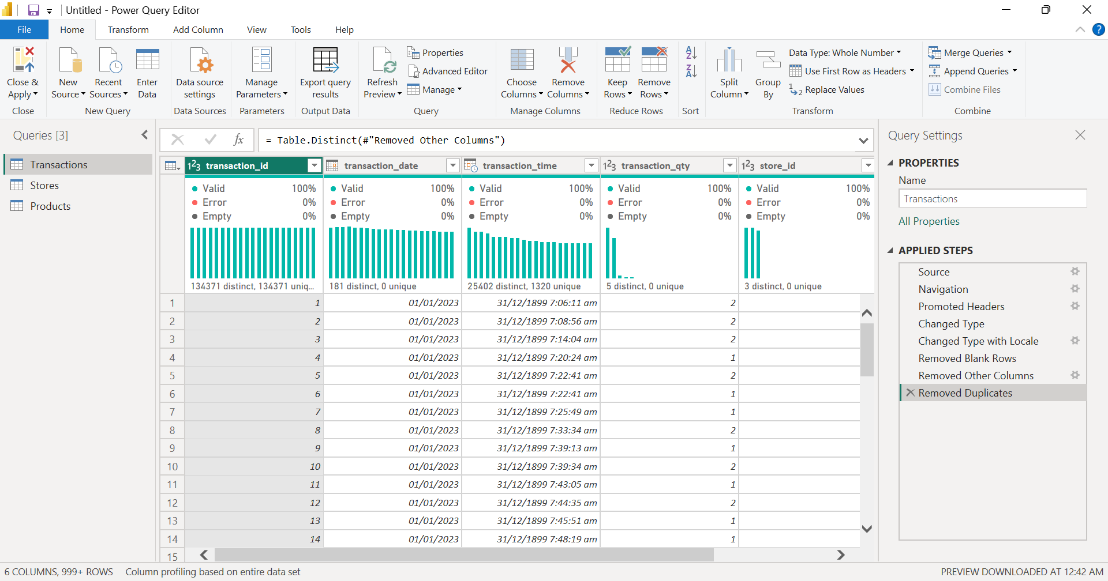
Hint: Choose the desired columns and click on “Remove other columns."
● Make sure to remove duplicates from each table. (Select all and then remove duplicates.)
● Close and apply the Power Query.
Marks: 10
Data Modeling
● Create relationships between tables in the Data Model View.
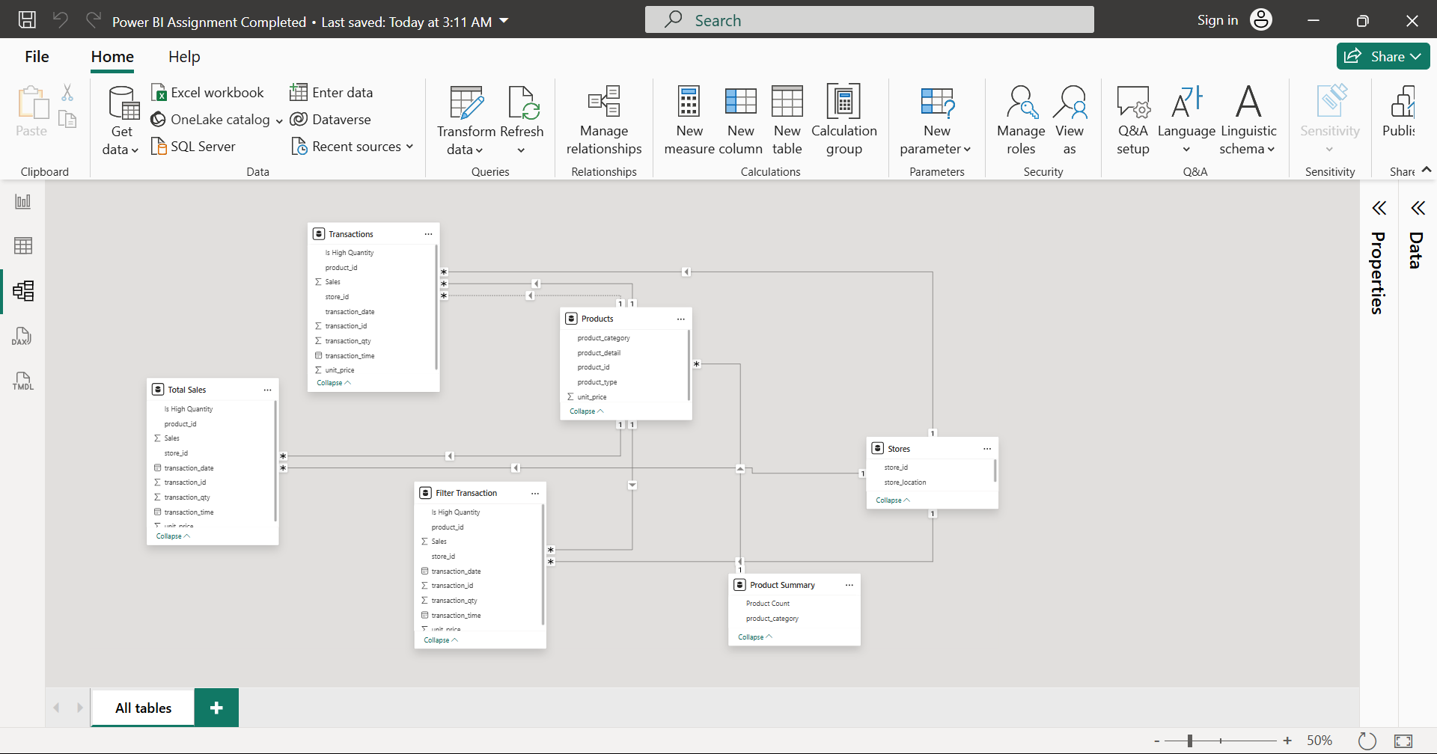
Marks: 12
Power Query Analysis
Perform the following tasks:
1. Create a column for Sales
○ Merge the column ”Unit price” from “products” to the “Transaction” table. ○ Create a custom column with the name Sales. (Add Column > Custom Column)
Sales = unit price x transaction_qty.
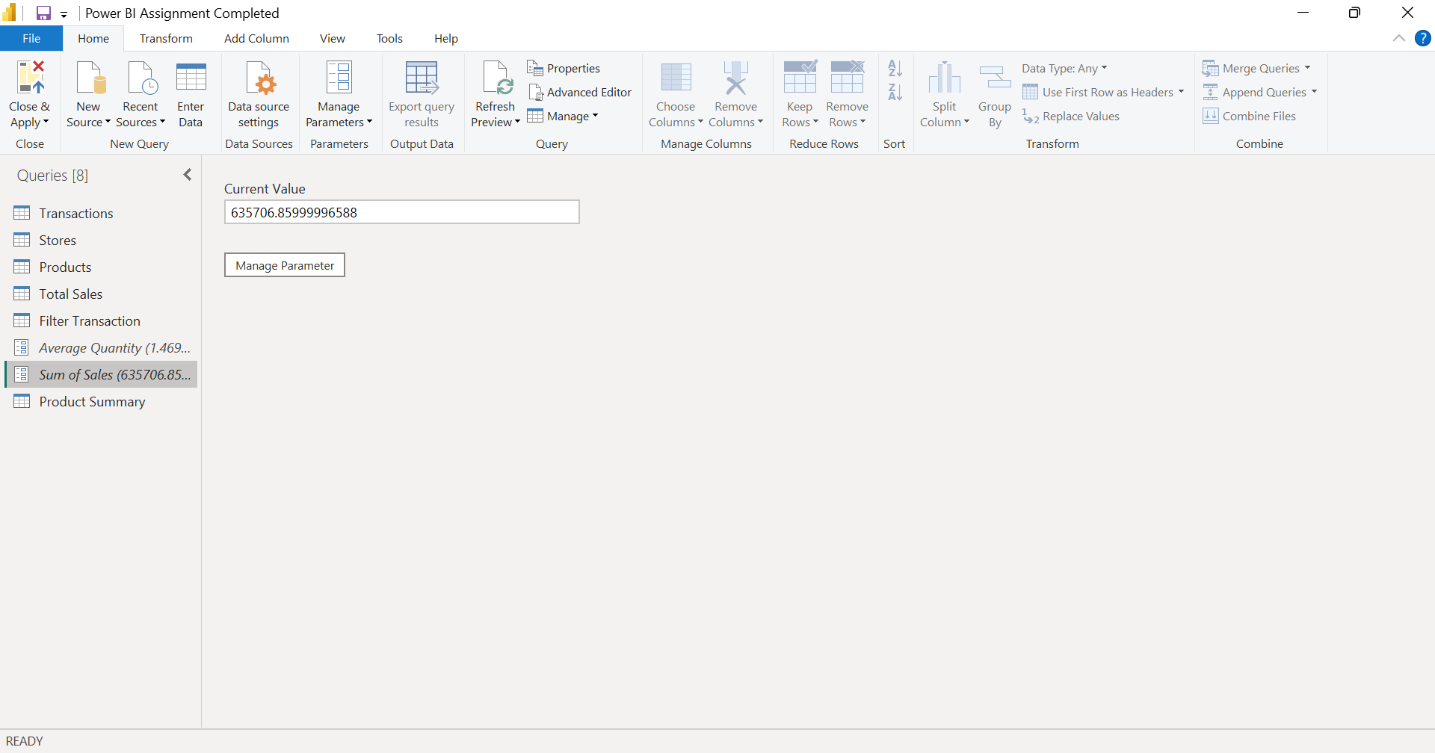
2. Conditional column:
○ Create a conditional column, Is High Quantity:
If transaction_qty > 4, return "Yes", otherwise "No".
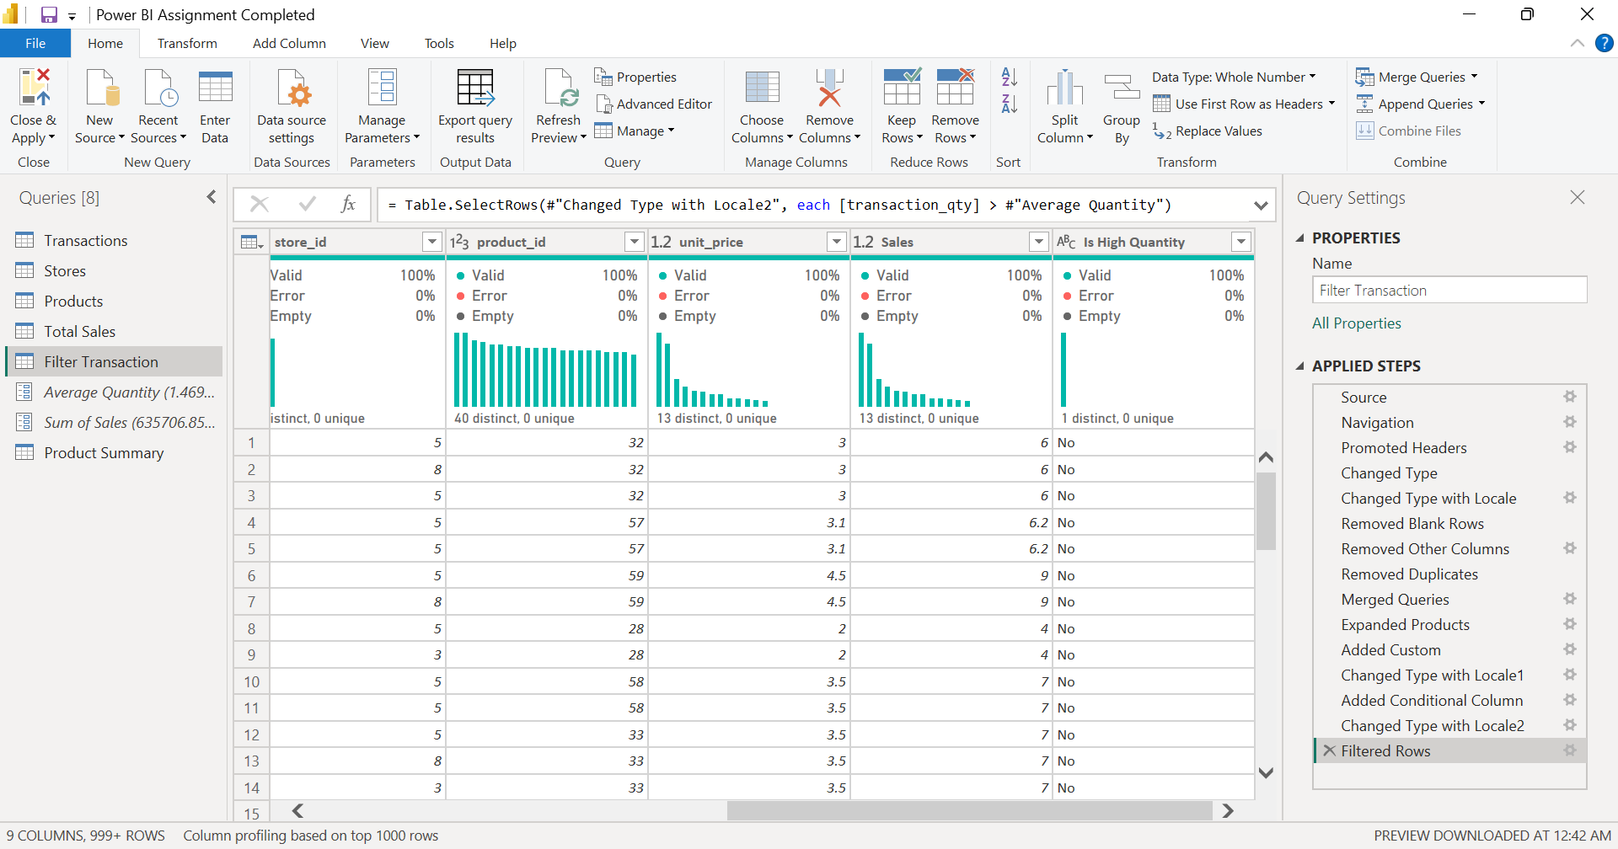
3. Parameters:
○ Calculate the given and store them as parameters:
i. Calculate Total Sales: Sum of Total Sales.
ii. Calculate Average Transaction Quantity: Average of transaction_qty.
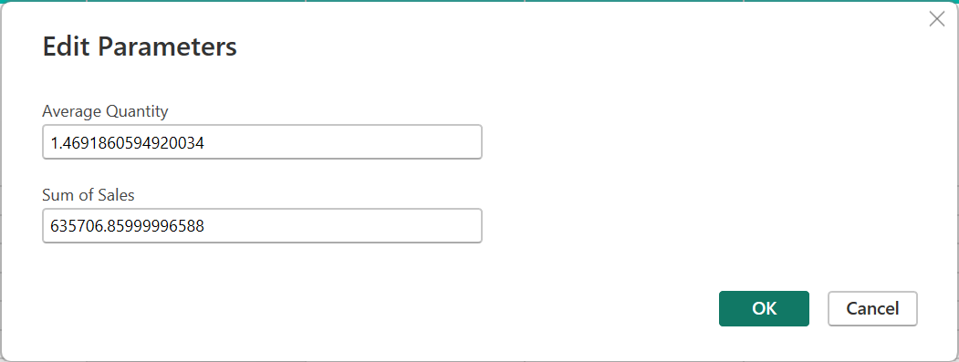
4. Filter based on parameters:
○ Create a duplicate of the Transactions Table.
○ Filter the transactions with a quantity greater than the parameter “ Average transaction quantity”.
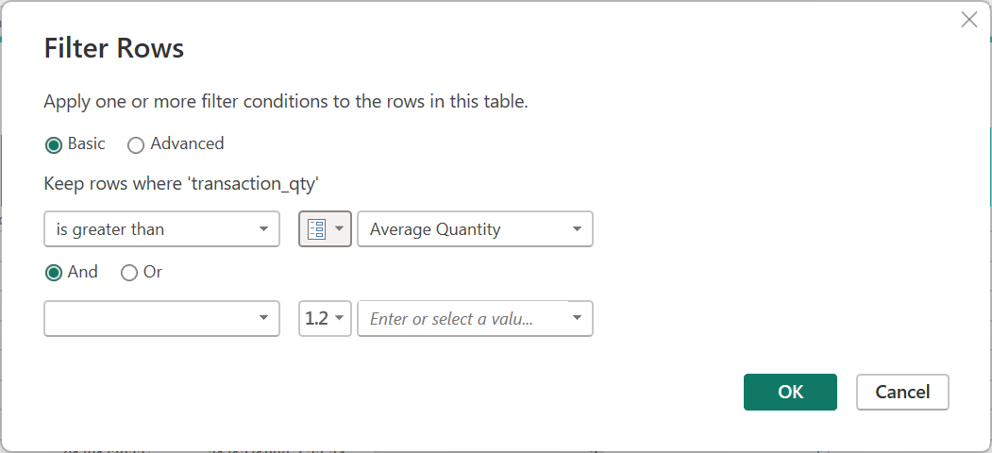
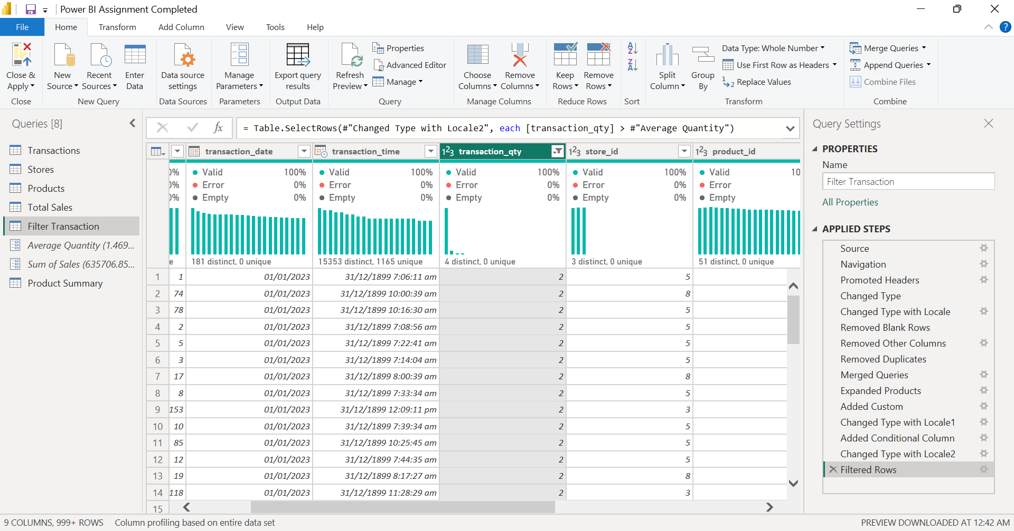
5. Sales Based on Location:
○ Merge Sales from “Transaction Table” to “Store” and show the aggregated value “Sum of Sales” in Stores table.
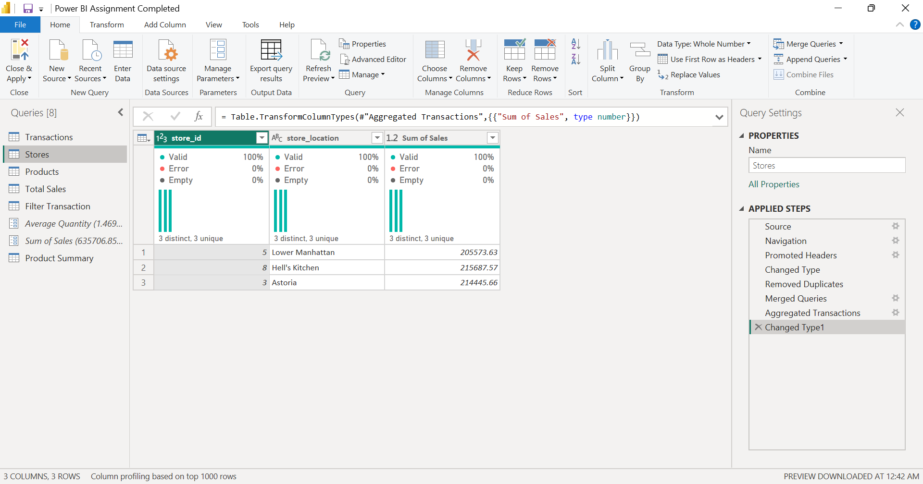
6. Count of Products in each product Category:
○ Create a duplicate of “Products”. Apply GroupBY to count products in each category. Rename this table as “Product summary”
